Caesar cipher example #1

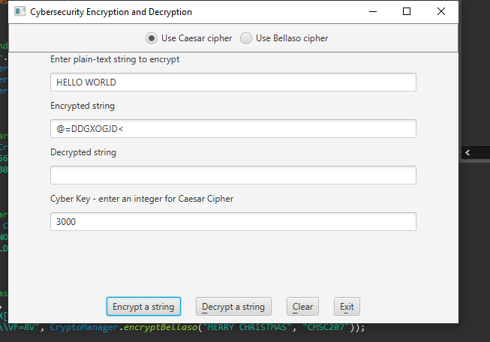

Caesar cipher example #2

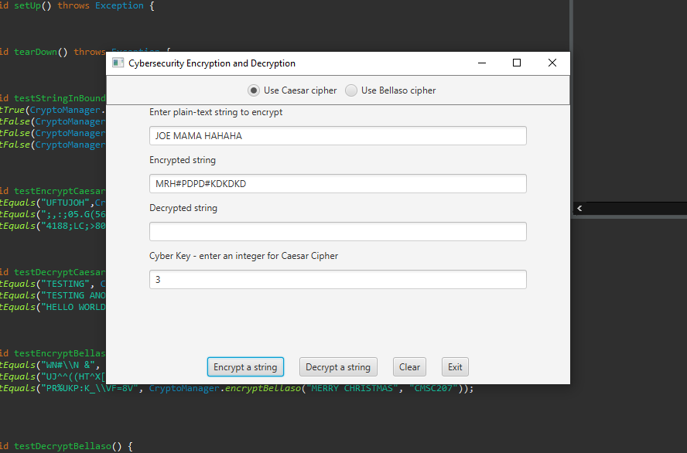

Bellaso cipher example #1

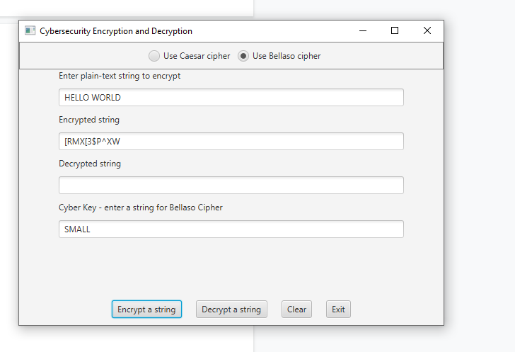

Bellaso cipher #2

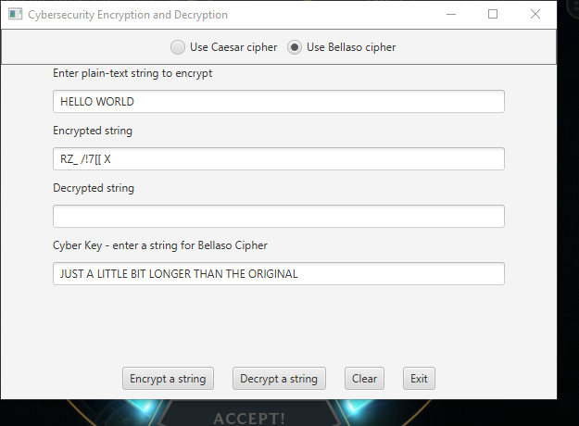

Test table

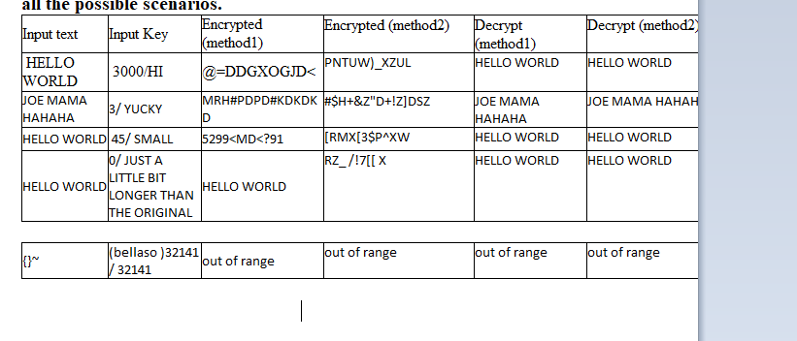

Lessons learned

During this project, I learned how to think like a programmer to solve a solution. Before this, the projects were relatively simple and didn’t require that much thinking, just more doing. This project required me to actually think about why something was working and why it was not working. I also had to use a lot of math to actually understand how to implement the ciphers so they were within range. I struggled with a lot of this project, I didn’t immediately understand how a bellaso cipher worked, so I had to watch videos on how it worked. At first, I implemented all the functions without checking the upper bounds and after I realized I had to do this, I had to redo all of my methods. I learned how to properly debug by running the program inside of my head. Figuring out what should happen and what algorithm was required to make it happen. If I would redo this project I would have paid more attention to the original instructions and made my pseudocode more comprehensive. I was successful with every part of this project.

Github screenshot

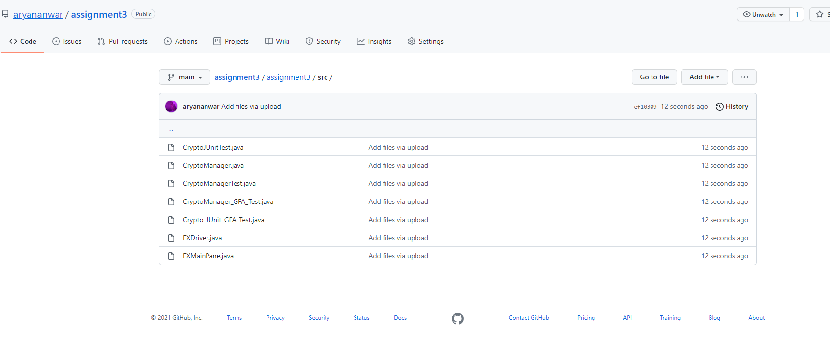

Check list

